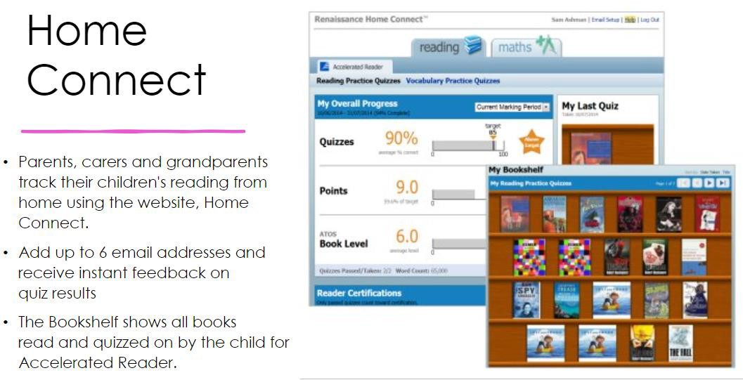

Woodpecker Class library day: Tuesday
AR check-in day: Wednesday
Year 6
Reading Expectations at Home

Dear Parents and Carers,

Please ensure your child reads for at least 20 minutes per day at home; this is preferably with an adult. Once they’ve finished a book, they can log on to Accelerated Reader (AR) and quiz on it at home or school. To login, visit our school website www.ladyj.kent.sch.uk, click on ‘Teaching and Learning’ and ‘Reading’ then click on the AR login link. You can also follow your child’s progress towards their AR target using Home Connect.

Accelerated Reader is a way for us to ensure that all children are choosing and reading books appropriate to their ability and age. At school, we can use it to track the children’s progress and support them.

Your child’s Accelerated Reader account looks like this:

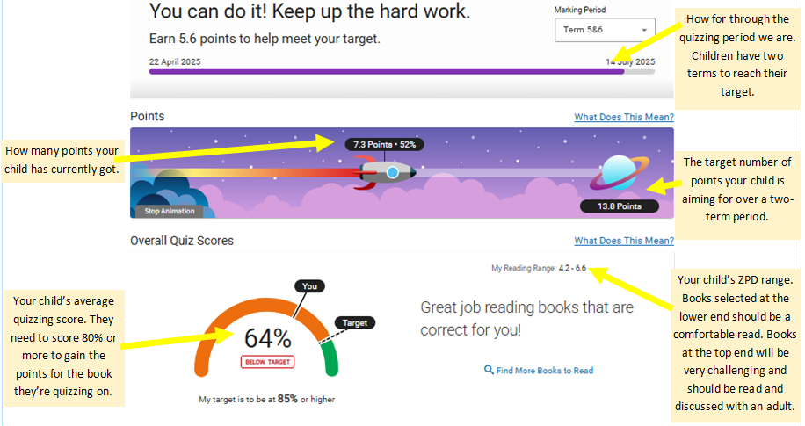

Home Connect
- Parents, carers and grandparents can track their children’s reading from home using the website, Home Connect.
- Add up to 6 email addresses and receive instant feedback on quiz results.
- The bookshelf shows all books read and quizzed on by your child for AR.

How parents can register with Home Connect
Thank you for your help and support with home reading.
If you would like to see a more detailed version of the school’s Home Learning policy, a copy is available our website.
If you have any concerns or questions in relation to home reading and logging into AR Home Connect, please feel free to contact us via email.
Mrs Parker and Mrs Burrell

- Visit our school website www.ladyj.kent.sch.uk
- Click on ‘Teaching and Learning’ and ‘Reading’
- Click on the AR login link
- Use your child’s details to log in (please see the teacher if you do know this login)
- Scroll down and click on:

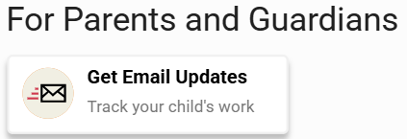
- Enter your name and email address (6 emails can be added)
- You will receive a confirmation email from Home Connect and once you have accepted this, you will receive emails about quizzes your child has completed and you can log in to check progress towards your child’s target.

