The rating is 9\10
By DAV PILKEY
Dog man got in to an explosion is anyone hurt . Then the nurse had a idea to swop body with dog’s and the cop.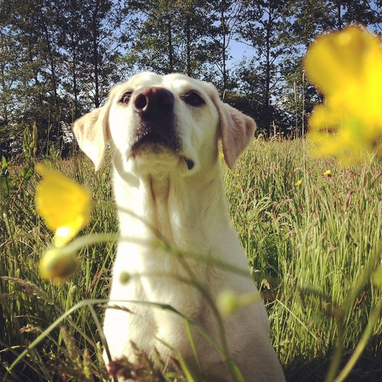
This Photo by Unknown Author is licensed under CC BY
This Photo by Unknown Author is licensed under CC BY-NC-ND
This Photo by Unknown Author is licensed under CC BY-SA

