Wayside school gets a little stranger
It is by louis Sachar
The book is about a school what gets more strange and more strange. I think of the book funny because lots of stuff is different and they are all pranking each other and there school is falling apart and it was scary for them probably but anyway it was a nice book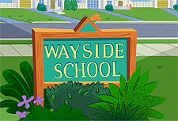
This Photo by Unknown Author is licensed under CC BY-SA-NC

