
Year 3: Term 5
Curriculum Newsletter &
Home Learning Expectations

Dear Parents and Carers,
Please have a look at our home learning expectations for the year ahead…

Home learning in Week 1 of each term:
Please share our curriculum newsletter detailing what the children will be learning in the term ahead. Please take the time to discuss this with your children, think about what they already know about the topics, what they are most looking forward to learning about and please help them to generate questions and curiosity about the topics.
Reading:
Please read with your child regularly. Ideally, we recommend that you hear your child read 5 days a week, for 15 minutes per day. It is essential that once your child has completed reading a book either independently or with an adult that they quiz on Accelerate Reader. If you require login details for your child, please get in touch with the class teacher.
MyMaths and Times Tables:
Maths home learning will continue to be set via MyMaths which is linked to their current class learning. In addition, children should be accessing TTRS as often as possible to help support their times tables knowledge.
Spellings
Please ensure your child has a go at learning and practicing each week’s words. These will come home on a Monday.

Home learning grid:
In addition to the above, each week, your child can select an activity from our home learning grid to complete. This is on the following page. Please encourage your child to carefully consider how to present their learning and to remember spelling, punctuation and grammar.

Children to bring in their Blue Homework Books each Friday to be shared in class.

Thank you in advance for your help and support with home learning. If you would like to see a more detailed version of the school’s home learning policy, a copy is available our website.

If you have any concerns or questions in relation to home learning, please feel free to contact your child’s class teacher via email.

Mrs Williams, Mrs Whitewood and Mr Phillips

Writing:
Our learning in English this term will be inspired by our History topic of the Ancient Egyptians. The children shall recall their understanding of non-chronological reports by writing about the importance of the River Nile and they will also learn about legends through studying the Legend of Osiris.

Reading:
We will be continuing to read our non-fiction text: MEGA (The Most Enormous Animals Ever) before moving on to reading about myths in the book – Tales of Ancient Egypt. While we have mixed the classes for the last two terms, children will be back in their classes for Reading in Term 5 and 6.

Maths:
We will be continuing our work around fractions and then moving on to reading both analogue and digital time and all things related to money. Please do engage your child in anything time related – it will be hugely beneficial to their understanding of the topic!

In the wider curriculum this term, we are studying:
History: Ancient Egypt and other Ancient Civilizations. The children will learn about the importance of the River Nile, the roles of the many different gods, everyday life in Ancient Egypt and the process of mummification.
Science: Muscles and Bones. The class will continue to look at Animals including humans – focusing on muscles and completing some investigations.
DT: Mechanical Systems: Pneumatic Toys. The children will be designing and making a working pneumatic toy.
PE: Dance with Mrs Selwood and Athletics with Miss Fuller in preparation for Sport’s Day.
Please ensure that the children arrive in their PE kits on Thursday and Friday, for both Chaffinch and Blackbirds.
Music: Writing music down.
Computing: Computer Systems - Journey inside a computer: Making Video Trailers
RE: Why do people pray?
PSHE: Identity, Society & Equality – Celebrating Differences.
French: Presenting Myself - By the end of this unit pupils will have the knowledge and skills to present themselves both orally and in written form in French.

After the success of mixing the classes in Reading, we will be working collaboratively across the classes in Science and DT this term. This will give the children the opportunity to continue to establish friendships across the classes and have the experience of different teachers.

Weather: As the weather warms up, please ensure that your child wears a named sunhat, brings a named water bottle into school and that they are wearing sunscreen. They may bring a small named bottle of sun cream into school which they will be able to apply themselves.
However, as the wonderful British weather can be so unpredictable, we would advise that your child continues to bring a named waterproof coat to school too.

If you have any queries, please do not hesitate to contact us, by email. Alternatively, please catch us at pick up time, however, please be aware that you will need to wait until all of the children have been collected so that we can ensure their safety.

We are looking forward to an exciting term ahead.
Kind regards,

Mrs Williams, Mrs Whitewood and Mr Phillips
k.williams@ladyj.kent.sch.uk, l.whitewood@ladyj.kent.sch.uk and l.phillips@ladyj.kent.sch.uk

Head | Heart | Hand
Imagine you were there when Howard Carter discovered Tutankhamen’s tomb. Write a diary or news report about the event.   | 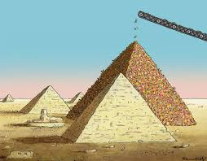  Find out more about the construction of the pyramids. Which materials would be best for pyramid building? | 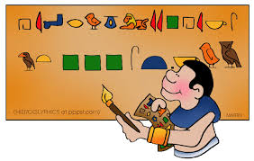  Design your own hieroglyphic alphabet using pictures relevant to life in Britain today.
Write a new adventure for the ‘Funny Bone’ skeletons. Use the link below to listen to the story being read.  https://www.youtube.com/watch?v=-olodqXs1ok | Use pasta shapes to make a skeleton. Label the bones.  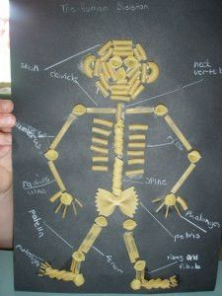 | Create your own muscle and bone quiz for the class.
Research and write up some real world examples of pneumatic devices. Can you include some diagrams to explain how they work? | Create a map showing the key places in Ancient Egypt. How has the country changed?  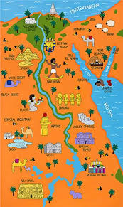 | Research a well-known prayer and copy it out in your best handwriting and then illustrate it.  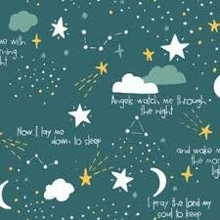
Resources:
https://www.childrensuniversity.manchester.ac.uk/learning-activities/history/ancient-egypt/explore-ancient-egypt/
https://www.natgeokids.com/uk/teacher-category/ancient-egyptians/
https://www.bbc.co.uk/bitesize/topics/zg87xnb

If you have any questions at all, please speak to us before or after-school or use class dojo. The Year Six Team

