
Year 3: Term 6
Curriculum Newsletter &
Home Learning Expectations

Dear Parents and Carers,
Please have a look at our home learning expectations for the year ahead…

Home learning in Week 1 of each term:
Please share our curriculum newsletter detailing what the children will be learning in the term ahead. Please take the time to discuss this with your children, think about what they already know about the topics, what they are most looking forward to learning about and please help them to generate questions and curiosity about the topics.
Reading:
Please read with your child regularly. Ideally, we recommend that you hear your child read 5 days a week, for 15 minutes per day. It is essential that once your child has completed reading a book either independently or with an adult that they quiz on Accelerate Reader. If you require login details for your child, please get in touch with the class teacher.
MyMaths and Times Tables:
Maths home learning will continue to be set via MyMaths which is linked to their current class learning. In addition, children should be accessing TTRS as often as possible to help support their times tables knowledge.
Spellings
Please ensure your child has a go at learning and practicing each week’s words. These will come home on a Monday.

Home learning grid:
In addition to the above, each week, your child can select an activity from our home learning grid to complete. This is on the following page. Please encourage your child to carefully consider how to present their learning and to remember spelling, punctuation and grammar.

Children to bring in their Blue Homework Books each Friday to be shared in class.

Thank you in advance for your help and support with home learning. If you would like to see a more detailed version of the school’s home learning policy, a copy is available our website.

If you have any concerns or questions in relation to home learning, please feel free to contact your child’s class teacher via email.

Mrs Williams, Mrs Whitewood and Mr Phillips

Writing:
Our learning in English this term will continue to draw inspiration from the magic and mystery of our Ancient Egyptian topic. This term, children will produce an extended piece of writing based on an Egyptian fairy tale.

Reading:
This term we will be studying an exciting adventure novel, ‘Varjak Paw’ by S.F. Said about a pampered pet kitten who ventures into the dangerous and murky world of the big city, when a suspicious man and his two vicious black cats appear to take over his family home. Children will continue to work on their reading fluency through a range of strategies in each session, as well as honing key comprehension skills across the term.

Maths:
We will be completing our unit of work on volume and capacity, before learning to tell the time in both analogue and digital, and completing the term with work on shape and statistics.

In the wider curriculum this term, we are studying:
History: The children will continue their learning about the Ancient Egyptians and other Ancient Civilizations. In this exciting topic, the children will learn about the development of the pyramids and the discovery King Tutankhamun’s tomb by Howard Carter and Lord Carnarvon.
Science: Building on the knowledge learnt in Year 2, the children will learn about the different parts of the flower as well as seed dispersion and pollination.
DT: Electronic charms using BBC Micro:bits.
PE: Tennis and Cricket with Miss Fuller, Mr Phillips and Mrs Whitewood.
Please ensure that the children arrive in their PE kits on Thursday and Friday, for both Chaffinch and Blackbirds.
Music: Recorders and reading musical notation.
Computing: Data Handling and Online Safety.
RE: Why is the bible so important? Linked to our trip to Canterbury Cathedral on Tuesday 30th June. More details to follow.
PSHE: Sex and Relationship Education – Letter to follow before commencement of learning.
French: My Family. The children will develop their knowledge and skills to talk about their family.

We will continue to work collaboratively across the classes in Science and DT this term.

Weather: As the weather warms up, please ensure that your child wears a named sunhat, brings a named water bottle into school and that they are wearing sunscreen. They may bring a small named bottle of sun cream into school which they will be able to apply themselves.
However, as the wonderful British weather can be so unpredictable, we would advise that your child continues to bring a named waterproof coat to school too.

If you have any queries, please do not hesitate to contact us, by email. Alternatively, please catch us at pick up time, however, please be aware that you will need to wait until all of the children have been collected so that we can ensure their safety.

We are looking forward to an exciting term ahead.
Kind regards,

Mrs Williams, Mrs Whitewood and Mr Phillips
k.williams@ladyj.kent.sch.uk, l.whitewood@ladyj.kent.sch.uk and l.phillips@ladyj.kent.sch.uk

Head | Heart | Hand
Write the ‘Ultimate plant quiz’.  Research parts of a plant, what plants need to grow and any other plant facts that interest you. Then create a quiz for your family or teachers to complete. You could write your questions or ask a grown up to help you to use ICT to create a quiz. | Create a family tree labelling your family members in French.  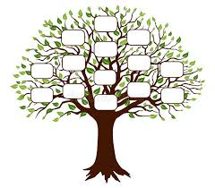 | Create a tiny garden. You will need a medium-sized container, some small pebbles and some potting compost. You can even use a clean plastic pot to make a mini pond in your garden! Follow the link for some ideas.  Create a tiny garden (youtube.com)
Ancient Egyptian Daily Life  Research an area of daily life in Ancient Egyptian times that interests you and present the information in an interesting way - as a leaflet, a poster, or a presentation!  Some interesting areas of daily life include:  - Food  - Clothing  - Housing  - Medicine | Research Ancient Sumar cuneiform writing and compose a letter to a friend  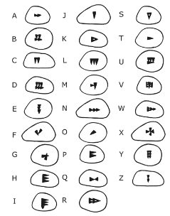  . | Try making a model of a flower. You could use modelling dough, paper or card, construction toys, or junk modelling. This about how you can make all of the features of the plant, including the stem, leaves, roots, petals and leaves.  .
Login to Language Angels  Have a go at the Pupil Games and practice the French vocabulary we are learning in our unit this term: ma famille.  https://www.languageangels.com/schools/  Class Username Password  Blackbirds Blackbirds  Chaffinches Chaffinches | Write an acrostic poem about the Indus Valley civilisation.  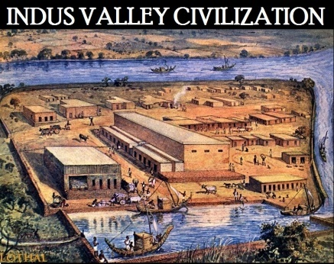 | Grow some plants from seeds such as cress. These can be grown on a shape or as a mini lawn in your tiny garden.
Resources:
- https://www.bbc.co.uk/teach/class-clips-video/articles/z4tjmfr (Indus)
- https://www.bbc.co.uk/teach/class-clips-video/articles/zmgnvk7 (Sumar)
- https://www.bbc.co.uk/bitesize/subjects/z2pfb9q (BBC Bitesize ‘Plant)
- Daily life in Ancient Egypt - BBC Bitesize (BBC Bitesize - Daily Life in Ancient Egypt)
If you have any questions at all, please speak to us before or after-school or use class dojo. The Year Six Team

