The Boy At The Back Of The Class
It is a story about a refugee boy . The boys name is Amet . The boy was lonely and sad.Until he beat up the bully the bully bullied his preasontation. The boy has lots of friends.Our class really liked this book.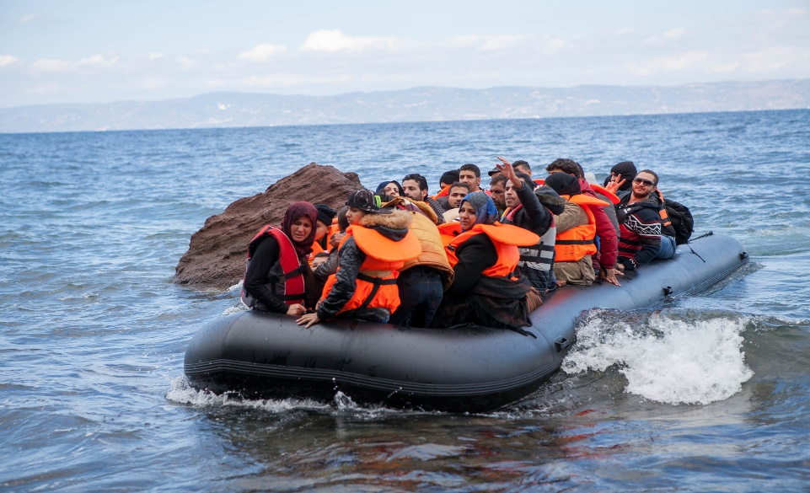
This Photo by Unknown Author is licensed under CC BY
The boy was very happy because he fit in with friends.His sister Syrah drowned on their journey. When he gos to school he is very happy .His dad got lost and his cat deid. When he have school trip with his friendshe is happy .his mum dewed in a tent/tp. He mum is very happy because she is in hevan.

