Krindlekrax
By Philp Ridley
Ruskin Splinter is a weak, thin boy and no one likes him (except Corky). But when Krindlekrax strikes, it’s up to Ruskin to save Lizard Street.
We really like this book and highly recommend it.
****
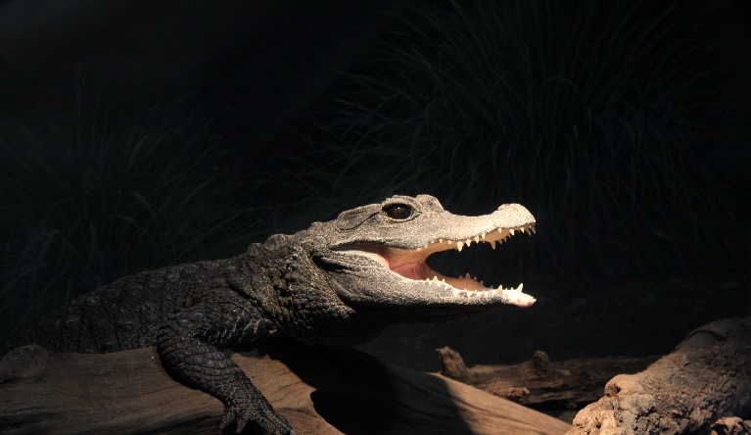
This Photo by Unknown Author is licensed under CC BY-SA

