Krindlekrax

Written by Philip Ridley

Our opinions

Sam: the book is really good its got really funny characters in it. There are some really sad bits like the main characters best friend dies by a big crocodile called Krindlekrax. At the end Ruskin (the main character)fights him and saves Lizard Street(the street Ruskin lives on.)

Ruby: The book is really good . It’s about a boy called Ruskin who has a best friend called Corkey . He sadly dies in the middle because he got attacked by a crocodile named Krindlekrax. At the end Ruskin fought Krindlekrax and made him never return.

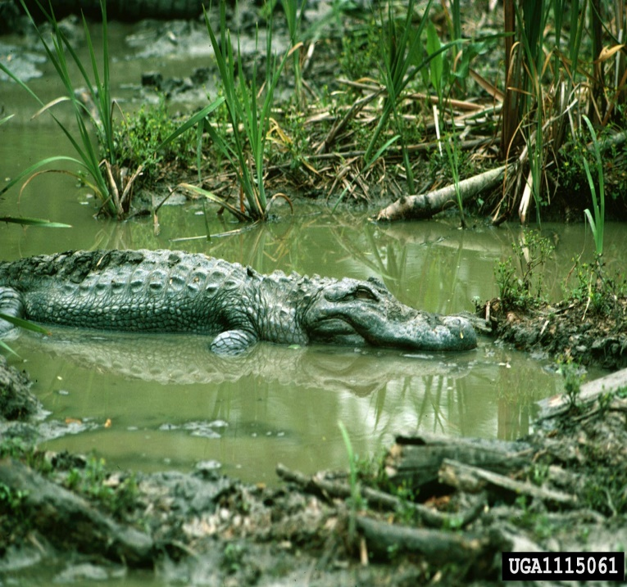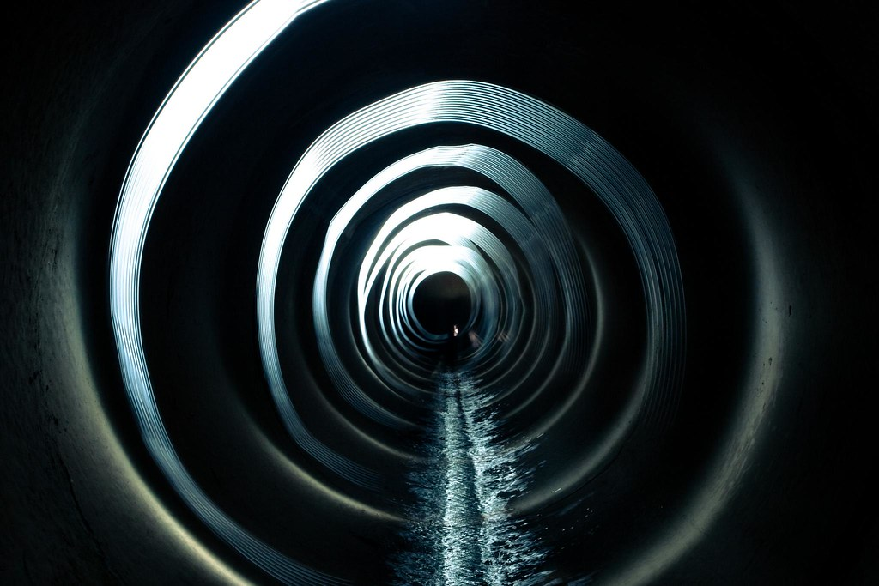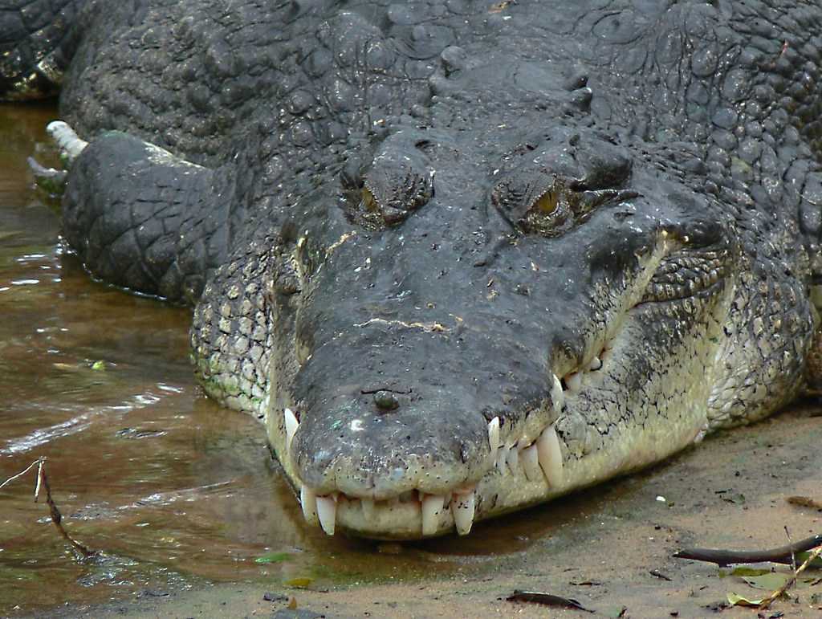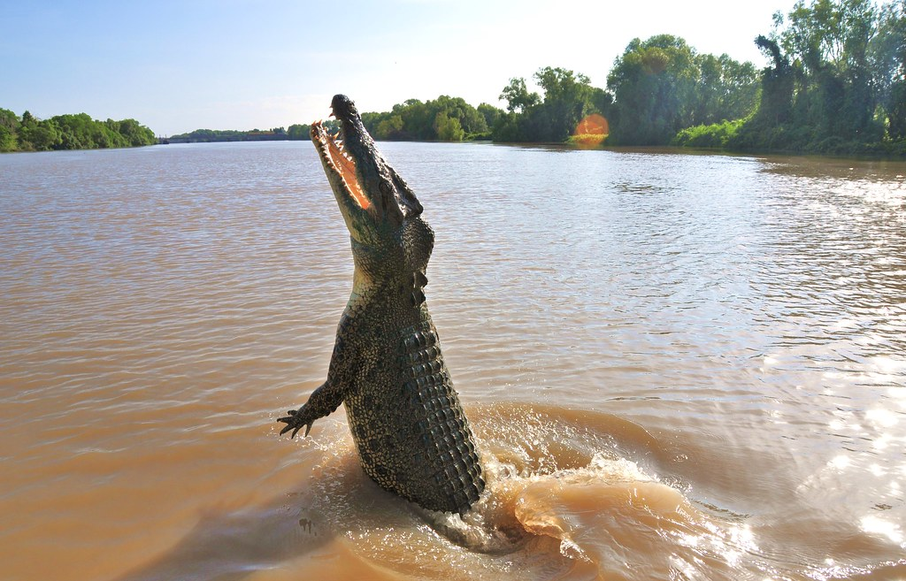
This Photo by Unknown Author is licensed under CC BY-NC-ND
This Photo by Unknown Author is licensed under CC BY
This Photo by Unknown Author is licensed under CC BY-NC
This Photo by Unknown Author is licensed under CC BY-NC
This Photo by Unknown Author is licensed under CC BY

