Krindlekrax
By Philip Ridley
Krindlekrax is a scary book about a crocodile .
A boy called Ruskin tames the myth the legend krindlkrax
on his own .

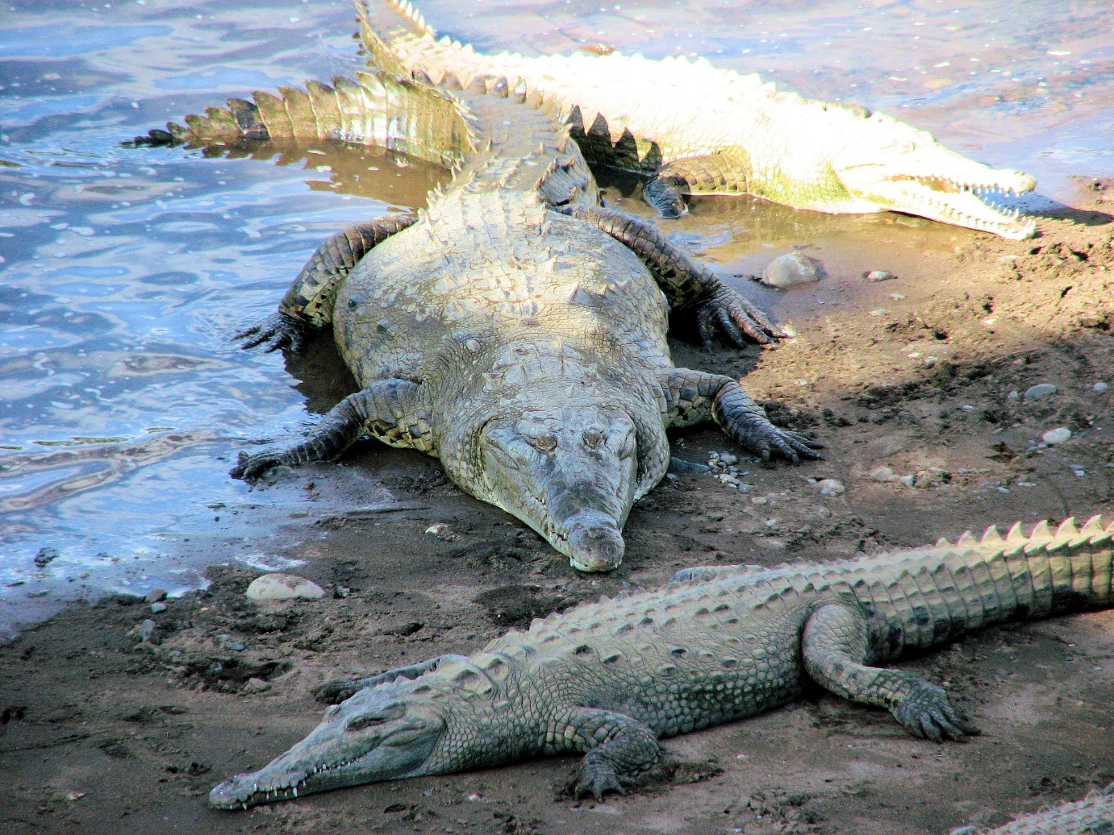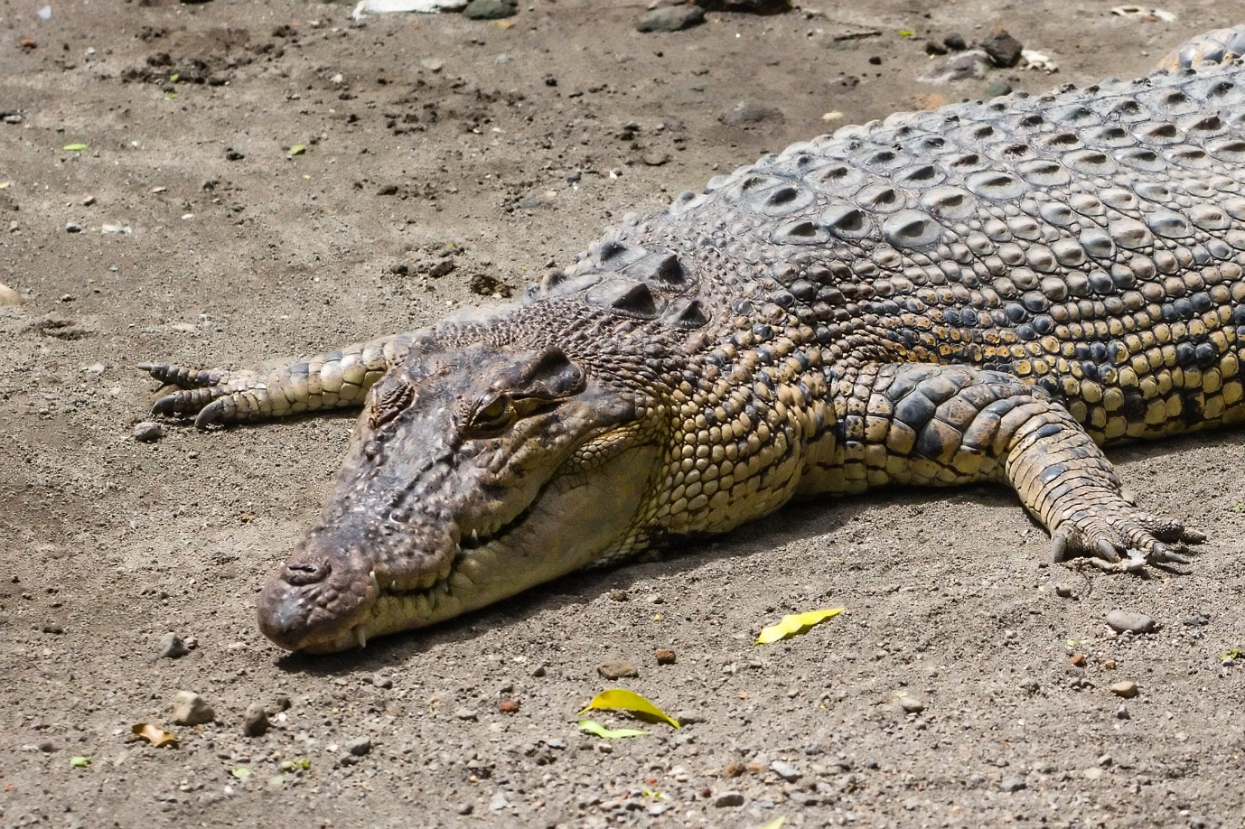
This Photo by Unknown Author is licensed under CC BY-SA
This Photo by Unknown Author is licensed under CC BY-SA

