THE TWITS:
BY ROALD DAHL

ABOUT
The twits are a awfully ugly couple but we love the book! It is about old, horrific, and horrendously disgraceful people who play pranks on each other . So their pet monkeys plot revenge because their forced to be upside down because Mr twit wants to make a circus.

RATING:
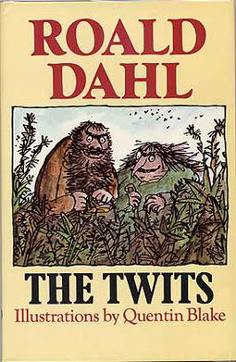LOVE THIS BOOK SO MUCH! We recommend this book and his other books (make sure to check those out)for people who like comedies like us! 5/5 *****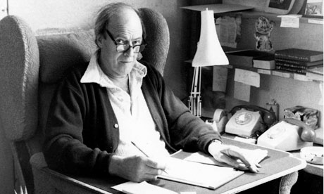
By roald dahl dahldahldahlAuthorilicensed under CC BY-SA
ROALD DAHLS WRITING HUT
This Photo by Unknown Author is licensed under CC BY

