DIARY OF A WIMPY KID
By Jeff Kinney
It is about a boy that goes through middle school and about the cheese touch and its very funny.
The best bit about it is when Rowley and Greg have a intense scene AKA terrible fight.
The weirdest character is FREGLEY.
His brother Rodrick has his own van and a band called Loded Diper.
There are 17 Diary of a wimpy kid Books and a few movies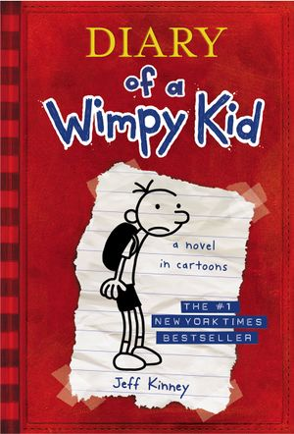.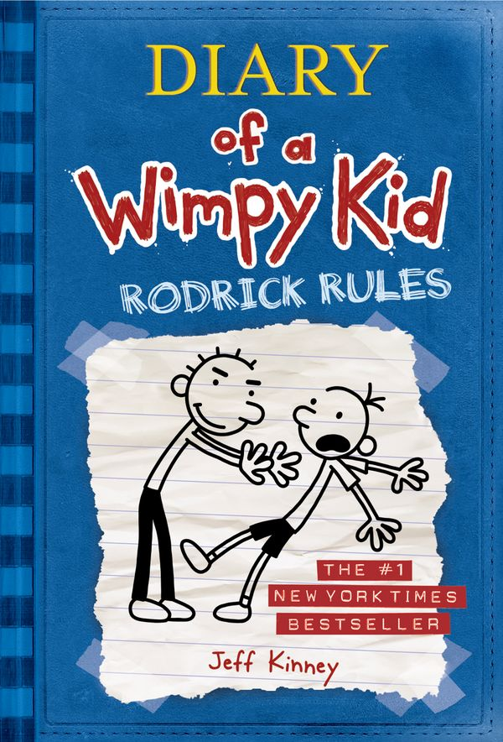
This Photo by Unknown Author is licensed under CC BY-SA
This Photo by Unknown Author is licensed under CC BY-SA

