Harry Potter
By J.K. Rowling
Lina: I think harry potter is a Classic idea of witchcraft and wizardry. My favourite character was Hermione granger because she is smart and mature.
Zara: I think that Harry Potter is a very bad idea to be a movie because it has It is scary so don’t let your little kids and babies
This Photo by Unknown Author is licensed under CC BY-SA-NC
watch harry Potter! Only for big 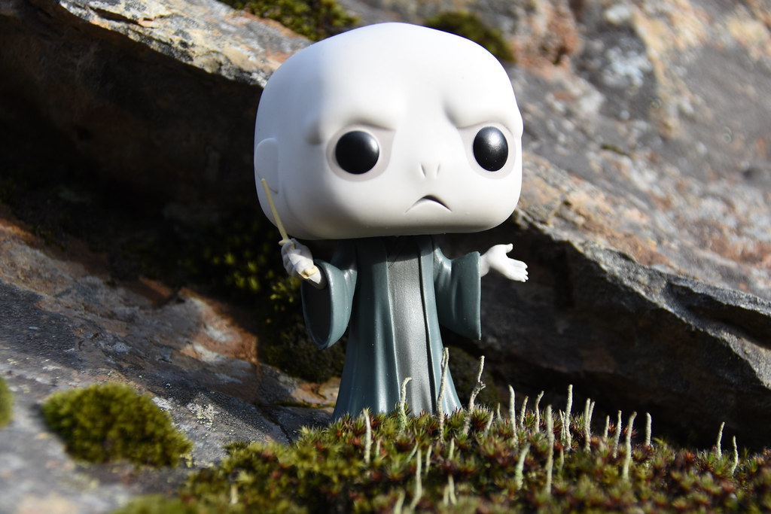kids. Its rated 12 plus.It is definetly a good book for teen readers! 5 star rating!
This Photo by Unknown Author is licensed under CC BY


This Photo by Unknown Author is licensed under CC BY-SA
This Photo by Unknown Author is licensed under CC BY-NC-ND

