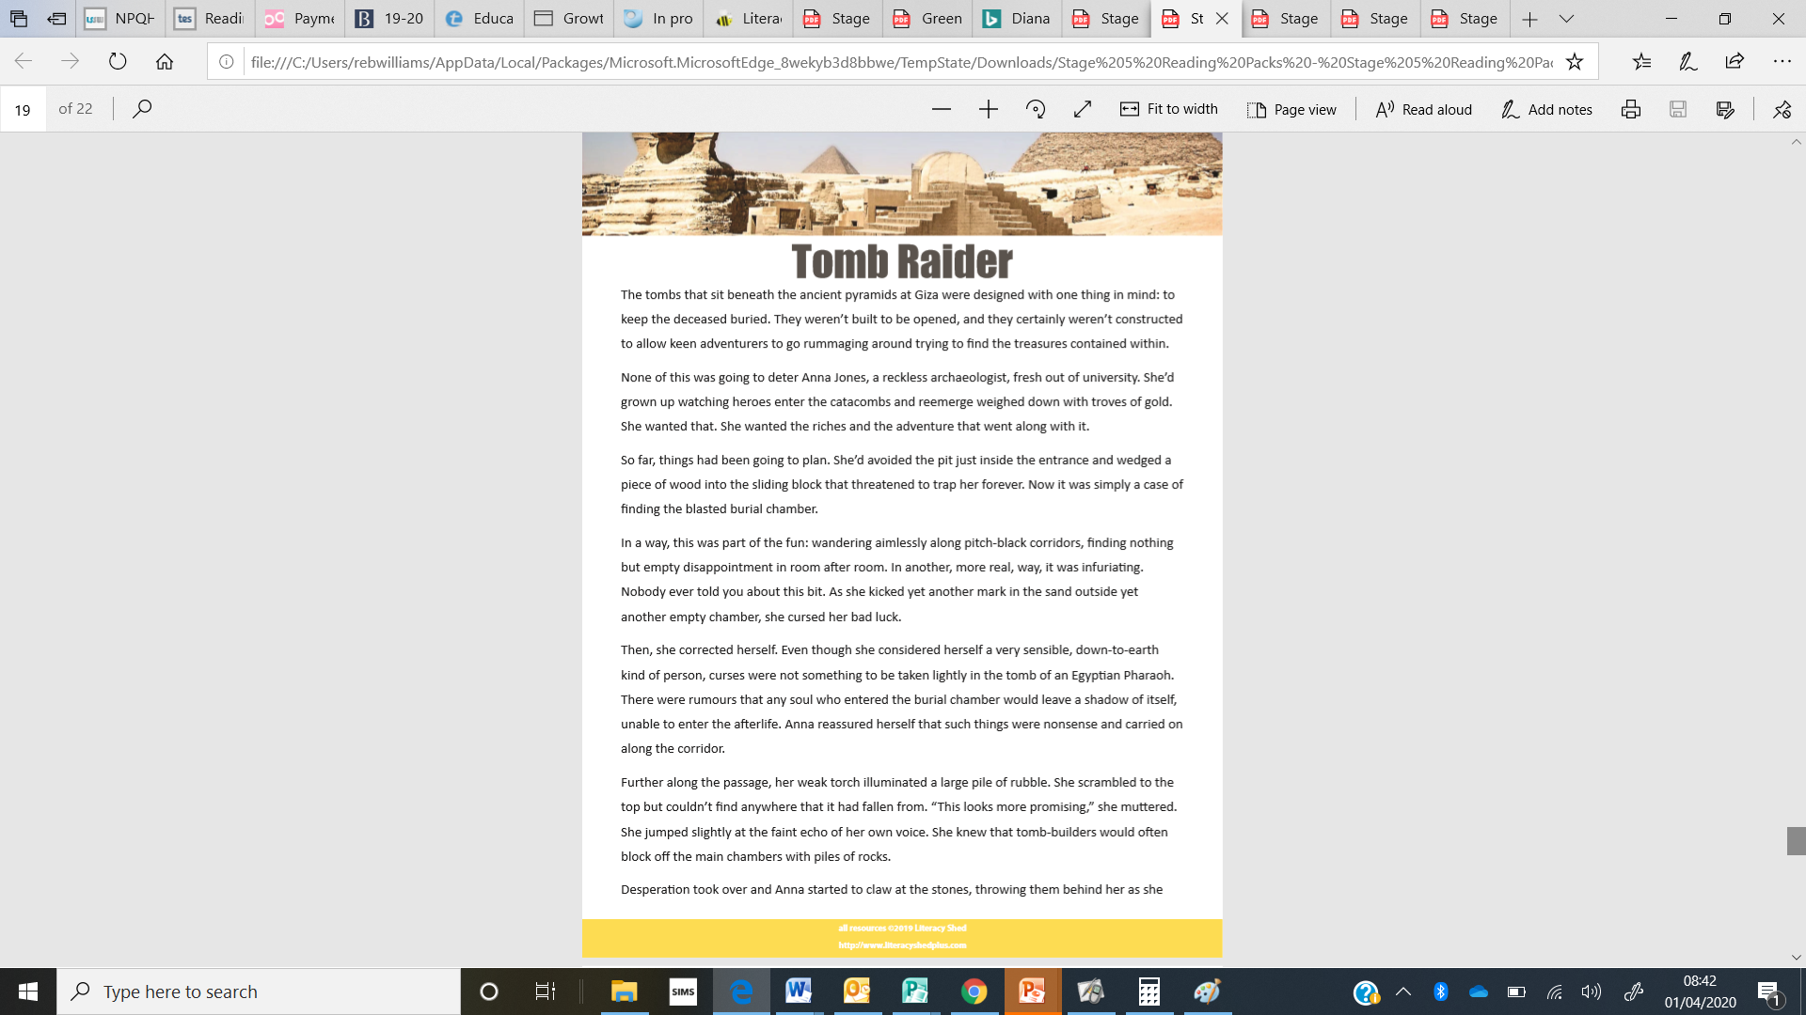

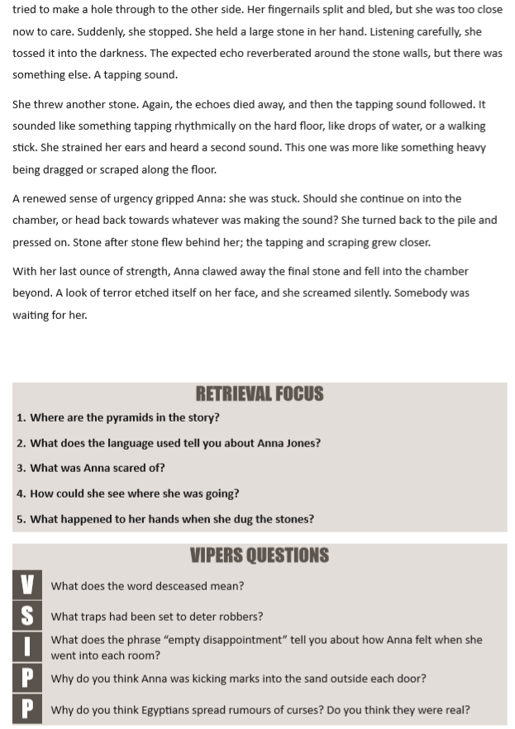
Answers
1) Giza (1mark)
2) She was interested in archaeology. (1 mark)
She was interested in archaeology. She was fearless and wanted adventure. (2 marks)
She was interested in archaeology. She was fearless and wanted adventure. She wanted to get rich from it. (3 marks)
3) The curse - The shadows of souls left behind in the burial chamber. (1 mark)
4) She used a torch. (1mark)
5) Her fingernails split and bled. (1 mark for both answers)

V) dead (1 mark)
S) The pit outside the entrance.
A sliding block to trap. (1 mark for each – total = 2 marks)
I) She was disappointed / sad to find there was nothing in it. (1 mark)
P) So she would have a visual reminder about which doors she had already been through, so she wouldn’t waste time by visiting the same doors twice. (1 mark)
So she would have a visual reminder about which doors she had already been through, so she wouldn’t waste time by visiting the same doors twice. It was a way to mark the door without vandalising the tomb – she was already carrying a torch so holding a pen and paper would be difficult. (2 marks)
P) To deter (put off) people from visiting their burial chambers. (1mark)

To deter (put off) people from breaking into their burial chambers. They were often buried with troves of gold and they didn’t want robbers to steal it. (2marks)

