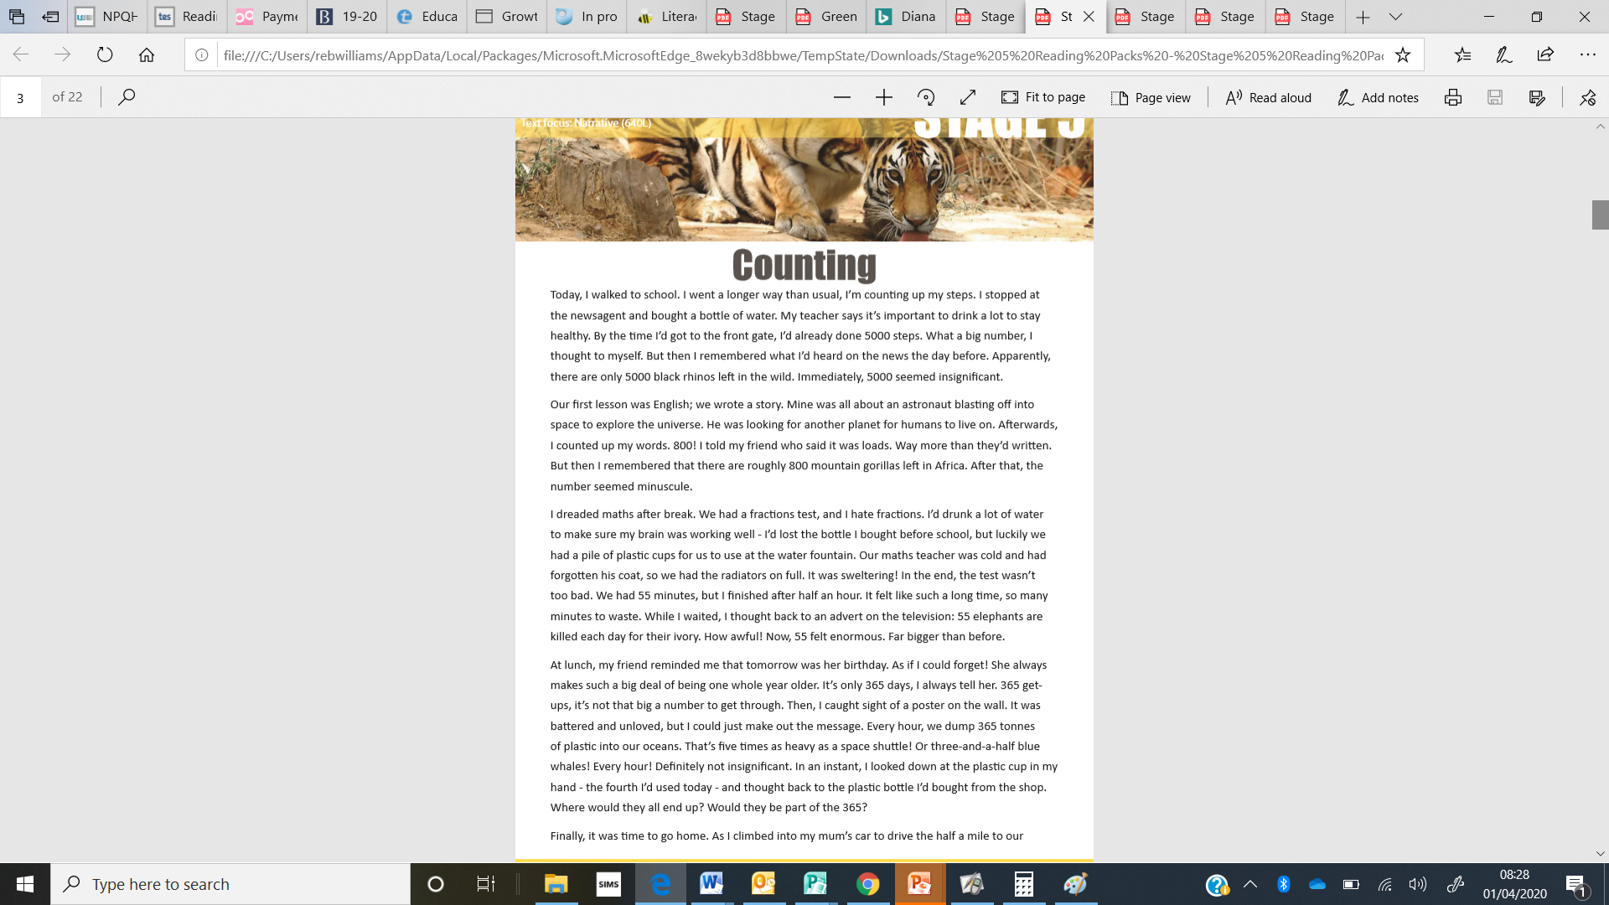

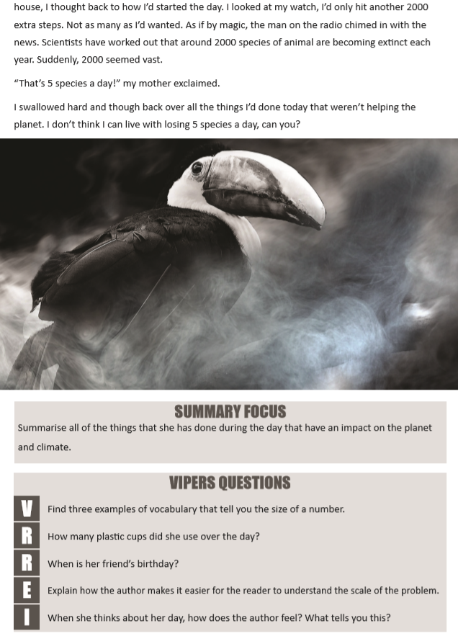

Answers:
Summary focus:
Bought a bottle of water. Used a plastic cup. Radiators on full. Driven a short distance. (1 mark for each point. 4 marks available in total)
V: Insignificant, loads, miniscule, enormous, insignificant, vast (1 mark for each correct answer – 3 marks available in total)
R: 4 (1 mark)
R: Tomorrow / the next day (1 mark)
E: By linking the number of animals and waste to things that happen in her day that seem small at the time (1 mark)
I: Shocked, worried, sad and angry. (1 mark)
Shocked, worried, sad and angry. She swallowed hard and talks about how she can’t live with losing 5 species a day (2 marks)

