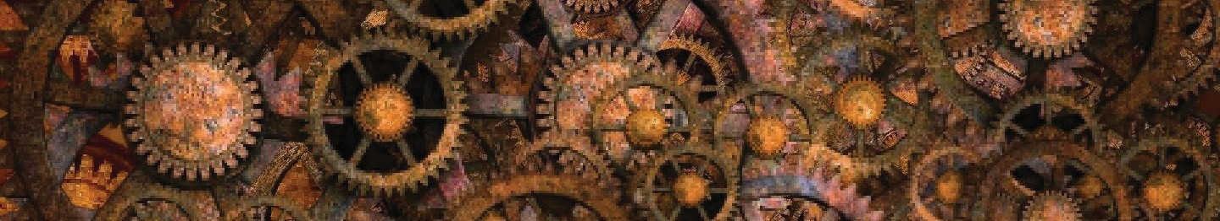
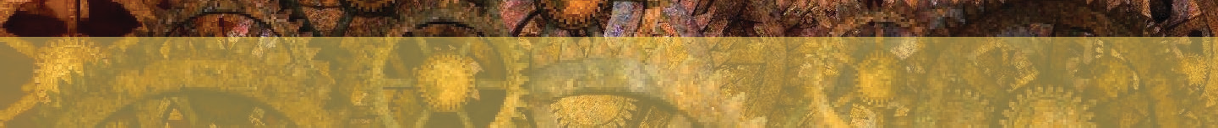
The Contraption
Unit focus: Magic and Mystery
Text focus: Narrative (800L)
STAGE 5
“You’re doing it wrong again!”
Hanna sighed. Pippa was her best friend, but she was so uptight about everything. “I’m sorry!” Hanna called back. She heard a mufled grunt in the mechanism above her. Enormous metal cogs bit into each other, and steam hissed out of well-worn seals in the copper piping that covered the walls like a maze.
The contraption had been Pippa’s idea. She was the brains behind the whole thing. Hanna tried to consider herself the brawn, but one look at her scrawny arms and sparrow legs told her that wasn’t true either. They’d been working on it together for the last few months, and it was finally getting close to testing time.
Something whistled in the bowels of the machine. Hanna heard her friend whoop and holler and bang her wrench on the metalwork. “It’s working,” Pippa called down. “Get her wound up, and we’ll be ready to test it.”
The winding rod was slick with sweat, so Hanna wrapped an oily rag around it and started to wind it slowly. There was a lot of resistance. She knew that the other end of the rod was attached, via
a system of cogs and pulleys, to a screw that wound down into the river below. By winding the wheel, she’d start to draw up water into the enormous sump up above. From there, it would be turned into steam that would power the contraption.
A strong wind picked up outside. Hanna heard the creak of the wooden masts twisting as the sails caught the breeze. The contraption rocked but steadied quickly. Sweat dripped into Hanna’s eyes, but it would all be worth it. That was the beauty of her friend’s new creation. Pippa wasn’t content with just being amazing at harnessing the steam, she was, above all else, an alchemist.
Hanna still remembered the day when Pippa came bursting out her lab with a small vial of vivid green liquid. “This is Infinitum!” she’d shouted. Hanna knew she must have looked perplexed

because Pippa had grabbed her by the hand and dragged her into the lab. There, a wheel no bigger than a coin was mounted on an axis. As they both watched, it spun, and spun, and spun. And it didn’t stop.
“Infinitum actually generates energy when it it gets hot!” Pippa exclaimed. “The wheel spinning on the bearing generates a small amount of heat through friction. This new liquid turns that heat back into more energy. It will never stop spinning!”
Fast-forward a few months and Pippa had built the contraption. She didn’t have enough Infinitum to power the machine; instead, she was planning to use it to heat the steam-engine. Providing they drew enough water into the super-hot centre of the machine, it would never slow down and never stop.

Hanna gritted her teeth and wrenched the wheel harder. She heard her friend call down from the hatch up above, “It’s full...you can stop. Come and see this! It’s working!”

INFERENCE FOCUS
- How do you know that Hanna thinks Pippa is the more intelligent of the two?
- What do we know about Pippa’s character? Explain how.
- How did Hanna feel when Pippa first showed her Infinitum?
- What was Pippa’s biggest passion?
- How hard was Hanna working? How do you know?
V | VIPERS QUESTIONS  Which word or phrase tells you that Pippa is good at using steam to help her? What was the point of the wheel Hanna was turning?  What was the name of Pippa’s new creation?  Why do you think the new creation is called Infinitum?  Draw a labelled diagram of what you think the contraption might look like, using evidence from the text.
S
R
E
S

Answers:
- She refers to her as the brainy one
- She is focused but uptight - it tells us. She is very clever, especially at alchemy. She was amazing at harnessing steam
- Confused - she said she looked perplexed and Pippa had to explain
- Alchemy/being an alchemist
- She was working very hard - the rod was sweaty and sweat started to drip into her eyes

V: Harnessing
S: It would draw water up into the contraption to power the steam engine R: Infinitum - be careful not to confuse with the contraption
E: Because it allows the device to run infinitely/for infinity
S: Accept any diagram including pertinent information from the text

