19th October 1943
BRAVE YANK FLIES TO THE RESCUE

Pigeon Powers Through
A
t just after 9 am yesterday, an American soldier flew to the rescue of hundreds of British soldiers. G.I. Joe, a homing pigeon trained by the Signal Pigeon Corps in the USA, was responsible for one of the most daring, last-
minute rescues ever seen.
Acting on earlier orders, the 169th Brigade had stormed the Italian village of Calvi Vecchia. Their target was the remaining German soldiers

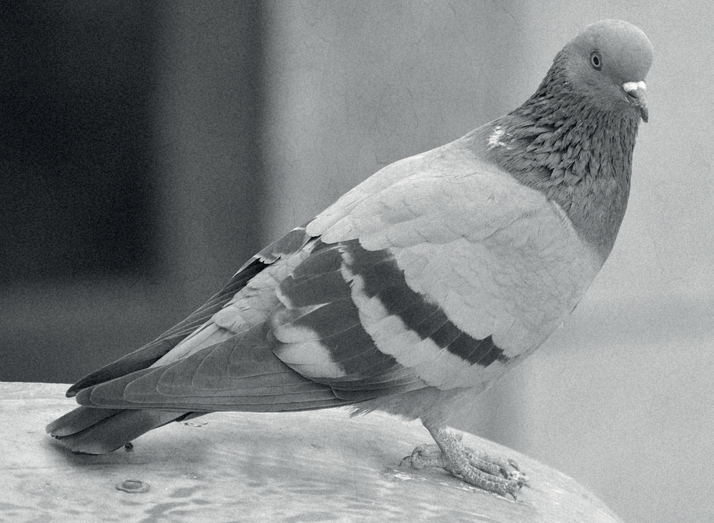
who still held it in a tentative grip. To aid their mission, air-support was to be provided by the US Air Force.
Unit focus: World War II
Text focus: Newspaper (960L)
The Wexbridge Crier
STAGE 5
It came as quite a shock when the Allied troops were able to take back the town far ahead of schedule. However, what should have been a time for muted celebration quickly turned to one of panic.
“We knew the Yanks were on their way to us, but the damned radio had packed in. We had no way of letting them know we had taken the city. No way to stop them sending their bombers,” Private J.L Pickard said on his return to base.
With hundreds of villages and nearly a thousand soldiers now at risk of being bombed by their allies, thoughts quickly turned to how else to solve the problem.
Fortunately, cool heads prevailed and the brave pigeon was called upon. A message was dispatched to the air base 20 miles away. In the end, G.I. Joe covered the distance in 20 minutes, flying at an amazing 60mph.
It was almost too late. It was only as the planes were warming up that the news arrived. Luckily,
it was joyously received, and the raid cancelled.
We reached out to the general in charge at the time. He said that with radios constantly in and out of service, pigeons like G.I Joe are often the most essential form of communication. This isn’t the first time that a pigeon has saved the lives of men.
Last year, a stricken RAF bomber ditched into the freezing waters of the North Sea. With their plane’s radio damaged, the men resorted to the homing pigeon that they carried aboard for such an eventuality.
That time, it was a bird named Winkie who flew over 120 miles to her home loft. There, the RAF was able to use the time taken from the plane ditching to her arrival to rescue the pilots within 15 minutes!
At the Wexbridge Crier, we’d love to hear about any animals that you know of that have helped with the war effort. Send your information to PO Box 42, Wexbridge, Leicestershire.

By M. Withers - War Correspondent

RETRIEVAL FOCUS
- What date was the newspaper written?
- How many soldiers were saved by G.I. Joe?
- Why did they have no way of letting the Yanks (Americans) know they had taken the town?
- How long did it take to rescue the pilots after Winkie’s message?
- Where did the RAF bomber crash?

S | VIPERS QUESTIONS  How did the soldiers feel when they first took back Calvi Vecchia? How did this change? Which word explains that the news arriving at the air base was good news?  Explain how the problem at Calvi Vecchia was solved.  How else do you think animals might have been used to save people in World War II? What are “allies”?
V
E
P
V

Answers:
- 19th October 1943
- Hundreds
- The radio had packed in (broken)
- 15 minutes
- The North Sea
S: Shocked and happy before becoming worried and nervous
V: Joyously
E: A pigeon was used to send a message to the air base in time
P: Any suitable prediction based on research or other understanding of the war
V: People fighting on the same side or for the same outcome

