
Year 6
Home Learning Expectations
Dear Parents and Carers,
Please have a look at our home learning expectations for the year ahead…

At Lady Joanna, home learning is handed out on a Thursday and collected in on a Tuesday.

Home learning in Week 1 of each term:
Share our curriculum newsletter detailing what you will be learning in the term ahead with parents/carers. Discuss what you already know about these topics and what you are most looking forward to learning.
Reading:
Please ensure you read for at least 20 minutes a day at home all year. Once you have finished a book, make sure you complete your AR quiz either at home or at school. How many of our 50 books can you read by the end of Year 6? Make sure to tick them off the list as you finish them.
MyMaths and Times Tables:
There will be a weekly task set on MyMaths to be completed at home. Please also practise your timetables regularly on Times Tables Rockstars.
Spellings and GPS:
Each week we will be working on our common exception words in our spelling lessons. Have a go at learning and practising each week’s words ahead of the lesson. You will also be set a grammar task to complete each week which should be stuck into your Home Learning books and handed in.

Home learning grid:
Each week you can select an activity from our home learning grid to complete. Make sure you consider carefully how to present your learning and remember spelling, punctuation and grammar.

Thank you in advance for your help and support with home learning. If you would like to see a more detailed version of the school’s home learning policy, a copy is available our website. If you have any concerns or questions in relation to home learning, please feel free to contact your child’s class teacher via email.
Year 6 Team

Year 6 Curriculum Newsletter & Home Learning
Autumn Term 1
Dear Parents and Carers,
Please have a look at our class curriculum and home learning grid for the coming term…

English:
This term we will be exploring the Suffragettes, learning about their fight for women’s right to vote and the impact they had on society.
Maths:
This term, children will be revising, refining and developing their place value knowledge and their skills with the four operations. It is pivotal that times tables facts and all addition and subtraction facts up to 19+9 are as secure as possible.

In the wider curriculum this term, we are studying:
History: Our topic this term will begin with our learning around the Suffragettes before we move onto World War 2 after PGL.
Science: We will be exploring the topic of light, identifying how light is made, moves and enables us to see.
Art: In Art, we will be looking at social activism within the art world and asking, ‘Can art change minds?’
PE: P.E. This term will be Badminton (Tuesday) and Hockey (Friday).
RE: We will looking at the role that art and architecture play in major religions.
PSHE: Our learning will focus on how news and media is presented and how we can try to identify what is trustworthy.

Head | Heart | Hand
Research a key figure within the Suffragettes movement. Create an information page to record all important findings. | Research a culture from around the world that interests you and produce a report that explains that culture and why you like it. (You may want to consider aspects such as music, cuisine, history, famous people, etc.) | Use the skill of sewing, stitching or knitting to create an item that you are proud of.
Draft a persuasive letter to your local MP to convince them to make a change that you feel would benefit the local area/environment. | You are delivered the following message:  “You’ve finally made it! It is everything you thought it would be.”  Write a response to explain where you are, how you got there and what you’re going to do next. | Create your very own homework task for the Hand.  Make sure that it is something that you can talk about.
Collect a set of data and present it in an appropriate graph. Some examples might be: favourite ice cream flavours; time taken to travel a certain distance; the population change of an area over time. | Create a page which includes all of the things you hope to achieve by time you finish Year 6 – make it as bright and colourful as possible. | Create your own circuit set of exercises that provides a full-body work out. Ensure that these are achievable as we may feature them within our PE lessons.
If you have any questions at all, please speak to us before or after-school or use class dojo. The Year Six Team
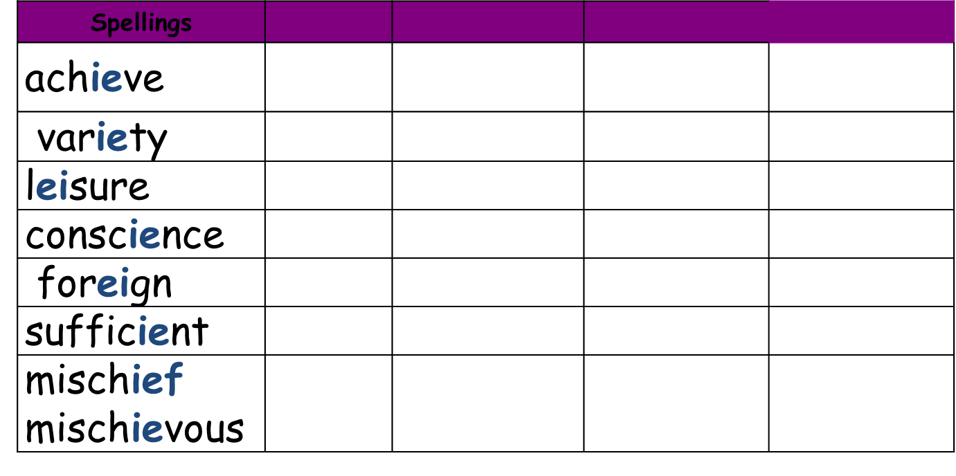
Due for Week 2:

Due for Week 3:

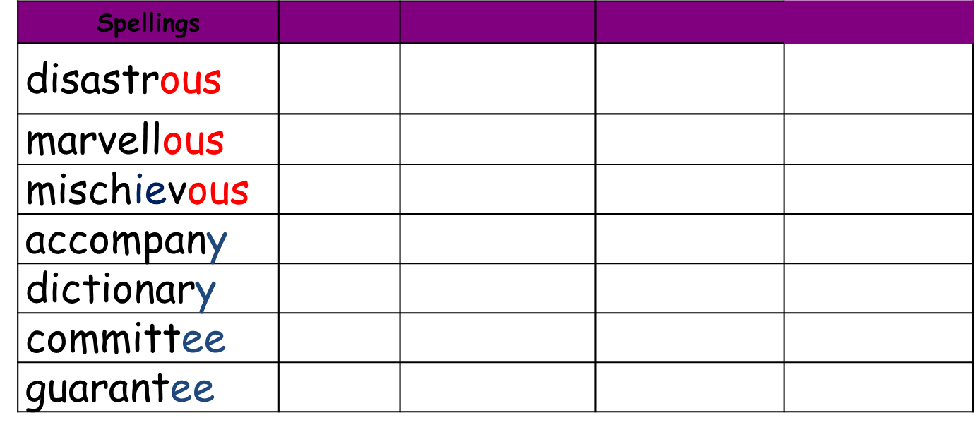

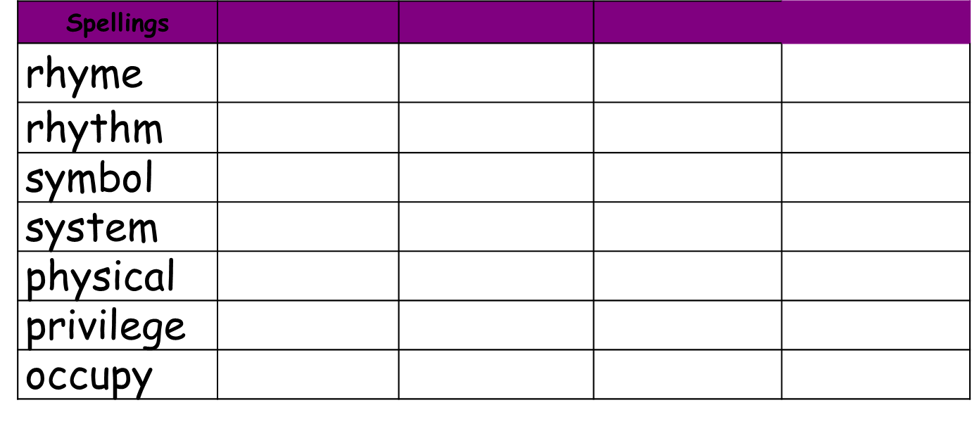
Due for Week 4:

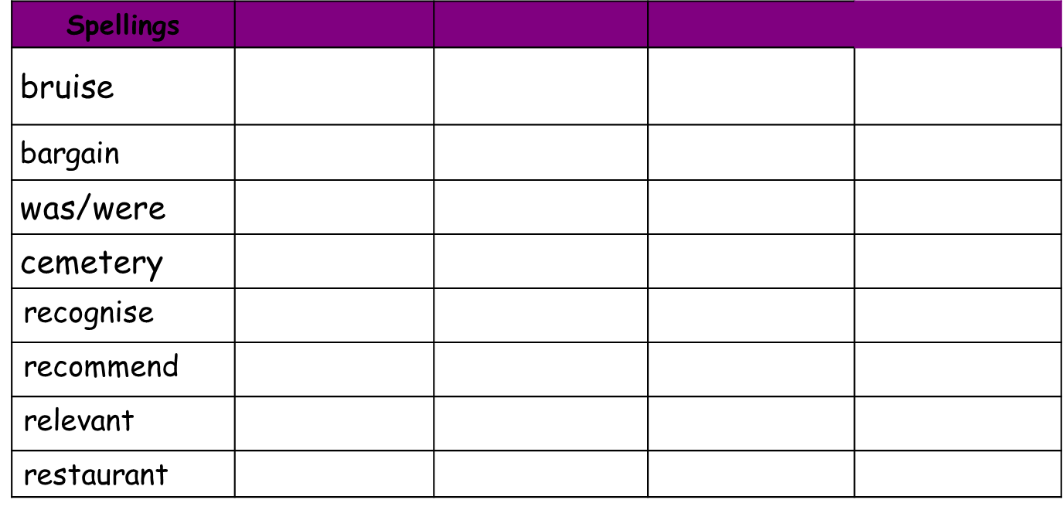
Due for Week 5:

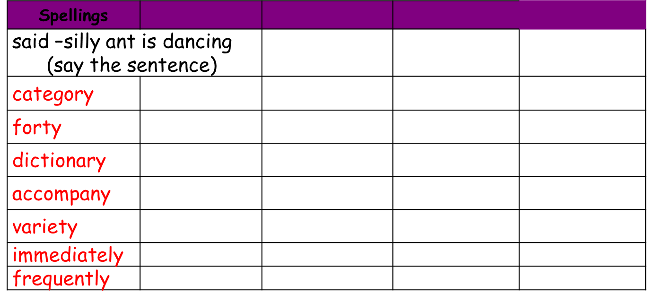
Due for Week 7:



